Alexa Development

**Key Terms:**

**API** - API is the acronym for Application Programming Interface, which is a software intermediary that allows two applications to talk to each other.

**Alexa Skill Kit** - The Alexa Skills Kit (ASK) is a collection of self-service APIs, tools, documentation, and code samples that makes it fast and easy for you to add skills to Alexa.

**AWS Lambda**- AWS Lambda is a serverless compute service that runs your code in response to events and automatically manages the underlying compute resources for you.

Context Diagram 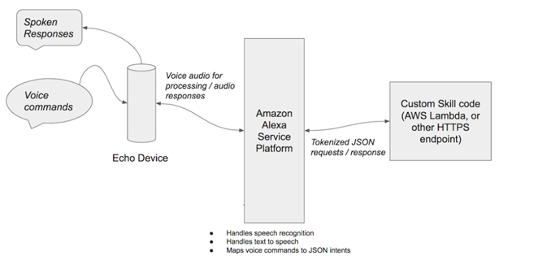

**Break Down-** A user speaks into the Alexa device. The audio gets sent to the Amazon Alexa Service Platform, which converts the audio to text and makes sense of the user’s request. It is then sent to a custom lambda which performs custom processing and forms a response. It then goes back to the Amazon Alexa Service platform and converted back to audio, which is then sent back to the device.

**Overview-** Developing an Alexa application is done in two parts. The first part is creating the Alexa Skill. This will map certain sentences and key words to intents and slots. Essentially, this allows for the lambda to understand what functions to trigger and what parameters to use. The next part is developing a lambda function which will process the intents and slots to generate a response.

Below is a walk-through video to develop a simple Alexa Skill

YouTube: <https://www.youtube.com/watch?v=ei_q4saWwcE>

Alexa Skill with WMATA

The Washington Metro Skill works by using an Alexa Skill with the Washington Metro API. To understand the API please visit: <https://developer.wmata.com/>

**Lambda**

**Handler:** index.handler

**Python:** 2.7

**Code Entry Type:** Zip File

**Existing Role:** lambda_basic_execution

**Template:** hello-world-python

**Lambda Python Script:** (Upload as zip file)



**Alexa Skill**

|  |  |
| --- | --- |
| **Intent Name** | **Question / Slots** |
| incidents | What are my alerts |
| incidentsByRail | are there any issues on the {rail_color} line |
| timingByStationAndRail | how long for the {rail_color} train to reach {station_name} |

JSON Editor File:



**Special Notes:**

The API Key may need to change in the script. If so please set up an account at <https://developer.wmata.com/> and get a new API Key generated and copy and paste into the script.

When trying to resolve issues you can go to the lambda function and check the logs.